Tech trend trace

Tech radar is also good

Stack Overflow Developer Survey 2021

**最流行的技术**

Python超越SQL成为我们第三大最受欢迎的技术，而Node.JS成为第六大最受欢迎的技术。

### [编程、脚本和标记语言](https://insights.stackoverflow.com/survey/2021#programming-scripting-and-markup-languages)

JavaScript 连续第九年成为最常用的编程语言。对于大多数开发人员来说，编程就是 Web 编程。Python与SQL交换了位置，成为第三大最受欢迎的语言。

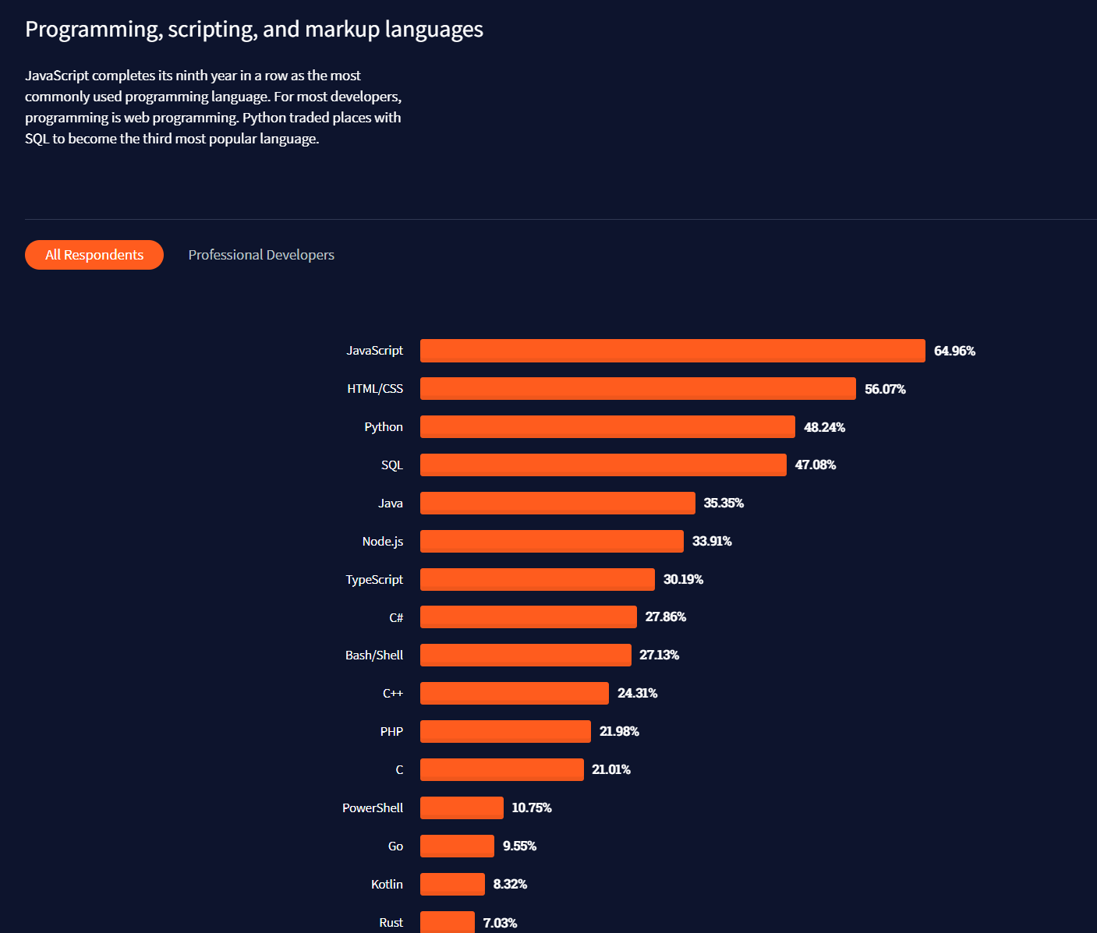

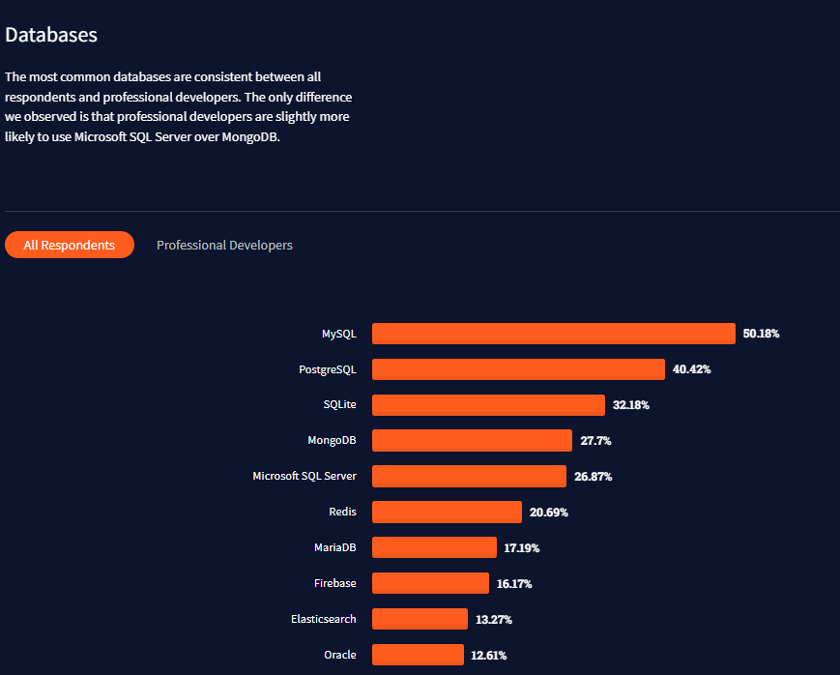

|  |  |
| --- | --- |
| MySQL | 50.18% |
| PostgreSQL | 40.42% |
| SQLite | 32.18% |
| MongoDB | 27.7% |
| Microsoft SQL Server | 26.87% |
| Redis | 20.69% |
| MariaDB | 17.19% |
| Firebase | 16.17% |
| Elasticsearch | 13.27% |
| Oracle | 12.61% |

### [Cloud platforms](https://insights.stackoverflow.com/survey/2021#cloud-platforms)

AWS maintains its lead as the most widely used cloud platform, but Google Cloud and Microsoft Azure made substantial gains from last year. It is worth noting that this is the first year that we broke out cloud platforms from our general platforms question.

[All Respondents](https://insights.stackoverflow.com/survey/2021#most-popular-technologies-platform)[Professional Developers](https://insights.stackoverflow.com/survey/2021#most-popular-technologies-platform-prof)

62,061 responses

|  |  |
| --- | --- |
| AWS | 54.22% |
| Google Cloud Platform | 31.05% |
| Microsoft Azure | 30.77% |
| Heroku | 24% |
| DigitalOcean | 17.67% |
| IBM Cloud or Watson | 2.55% |
| Oracle Cloud Infrastructure |  |

### [Web frameworks](https://insights.stackoverflow.com/survey/2021#web-frameworks)

This year, React.js surpassed jQuery as the most commonly used web framework.

[All Respondents](https://insights.stackoverflow.com/survey/2021#most-popular-technologies-webframe)[Professional Developers](https://insights.stackoverflow.com/survey/2021#most-popular-technologies-webframe-prof)

67,593 responses

|  |  |
| --- | --- |
| React.js | 40.14% |
| jQuery | 34.42% |
| Express | 23.82% |
| Angular | 22.96% |
| Vue.js | 18.97% |
| ASP.NET Core | 18.1% |
| Flask | 16.14% |
| ASP.NET | 15.74% |
| Django | 14.99% |
| Spring | 14.56% |
| Angular.js | 11.49% |
| Laravel | 10.12% |
| Ruby on Rails | 7.04% |
| Gatsby | 3.97% |
| FastAPI | 3.88% |
| Symfony | 3.85% |
| Svelte | 2.75% |
| Drupal | 2.39% |

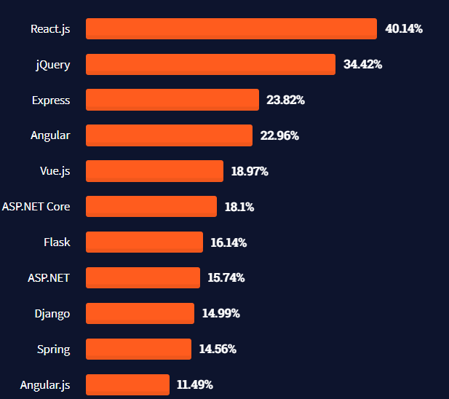

### [Integrated development environment](https://insights.stackoverflow.com/survey/2021#integrated-development-environment)

Visual Studio Code has a significant lead as the IDE of choice across all developers.

[All Respondents](https://insights.stackoverflow.com/survey/2021#most-popular-technologies-new-collab-tools)[Professional Developers](https://insights.stackoverflow.com/survey/2021#most-popular-technologies-new-collab-tools-prof)

82,277 responses

|  |  |
| --- | --- |
| Visual Studio Code | 71.06% |
| Visual Studio | 33.03% |
| Notepad++ | 29.71% |
| IntelliJ | 28.74% |
| Vim | 24.19% |
| Android Studio | 22.22% |
| Sublime Text | 20.47% |
| PyCharm | 19.29% |
| Eclipse | 15.87% |
| Atom | 12.94% |
| IPython/Jupyter | 12.63% |
| Xcode | 11.07% |
| Webstorm | 8.04% |
| PHPStorm | 7.47% |

## pulumi

接下来要出场的就是我们今天的主角 pulumi 了，它带给我们最大的不同是，可以用我们熟悉的语言来编排基础设施，例如 JavaScript、TypeScript、Python、Go、C# 等，这样带来的好处就显而易见了，我们不用在学习 HCL 了，选择我们自己熟悉的一种语言就好了，循环、条件、模块化等很容易就实现了。